**SMART PUBLIC RESTROOM USING MACHINE LEARING**

**Team members**

**622621121010 Dharaneeshwari. S**

**PHASE 1 Submission Document**

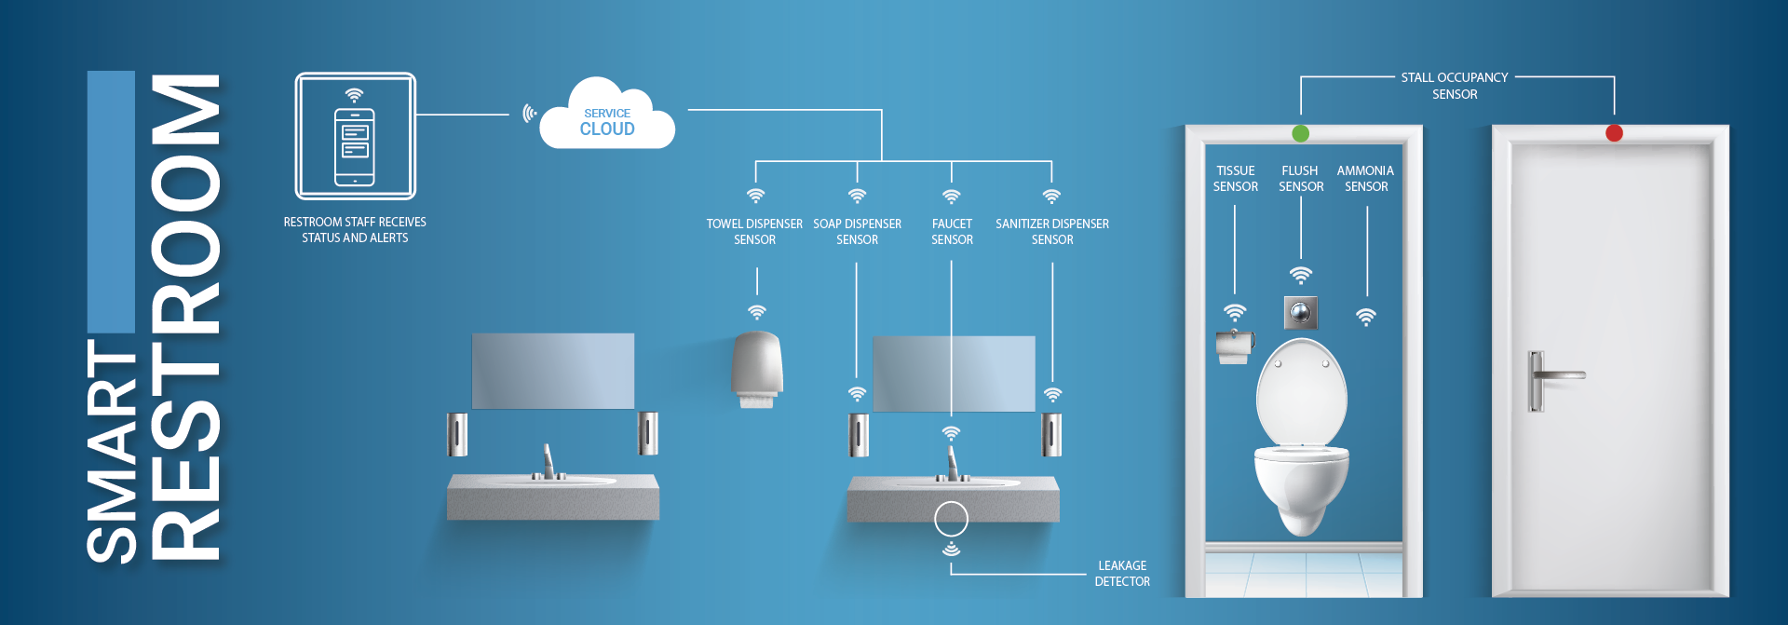

**ABSTRACT:**

Public restrooms play a vital role in maintaining hygiene and user satisfaction in urban environments. However, they often face challenges related to cleanliness, resource management, and user experience. In this context, the integration of machine learning techniques can revolutionize the way public restrooms are managed and maintained. This abstract presents a conceptual framework for a "Smart Public Restroom" system that incorporates machine learning modules to enhance various aspects of restroom management.

Smart public restrooms using machine learning (ML) have the potential to significantly improve hygiene, convenience, and efficiency for users and managers alike. ML can be used to automate a variety of tasks, such as:

* **Monitoring and predicting usage patterns:** ML models can be trained on historical data to predict how many people are likely to use a restroom at any given time. This information can be used to optimize staffing levels, ensure that supplies are adequate, and proactively address potential problems.
* **Detecting and reporting cleanliness issues:**ML-powered sensors can be used to monitor real-time cleanliness conditions in restrooms. For example, sensors can detect the presence of paper towels on the floor, empty soap dispensers, or overflowing toilets. This information can be sent to managers in real time, so that they can quickly address any issues.
* **Providing personalized services:** ML can be used to tailor the restroom experience to individual users. For example, ML-powered mirrors can recognize users and automatically adjust the settings for lighting, temperature, and music. ML can also be used to provide users with helpful information, such as the estimated wait time for an open stall or the availability of baby changing stations.

**MODULES :**

* **Occupancy Prediction Module**: Machine learning models can be used to predict restroom occupancy patterns based on historical data, weather conditions, and time of day. This information can help restroom operators optimize cleaning schedules and resource allocation, ensuring that restrooms are always available when needed.
* **Real-time Cleanliness Monitoring Module**: Sensors and cameras can be used to monitor the cleanliness of restroom facilities in real-time. Machine learning algorithms can analyze this data to detect cleanliness issues and alert maintenance staff when cleaning is required, thus ensuring a higher level of hygiene.
* **User Feedback Analysis Module**: Gathering user feedback through digital interfaces or surveys can provide valuable insights into restroom quality. Machine learning can be employed to analyze this feedback, identifying recurring issues and trends that can inform improvements in restroom design and maintenance.
* **Resource Management and Sustainability Module**: Machine learning can optimize resource usage, such as water and electricity, in public restrooms by predicting usage patterns and adjusting resource allocation accordingly. This promotes sustainability and cost-effectiveness.
* **Security and Vandalism Detection Module**: Machine learning models can be trained to detect suspicious activities, vandalism, or unauthorized access in restrooms through image and sound analysis. This can enhance the security of the facilities and deter potential misconduct.
* **Accessibility Enhancement Module**: Machine learning algorithms can be employed to improve the accessibility of restrooms for individuals with disabilities. This includes automated door opening systems, adaptive signage, and smart fixtures that adjust to the specific needs of users.
* **Queue Management Module**: Predictive modeling can be used to estimate restroom waiting times based on current occupancy and historical data. This information can be communicated to users through mobile apps or digital displays, enhancing their overall restroom experience.
* **Data collection module:** This module would be responsible for collecting data from a variety of sensors in the restroom, such as occupancy sensors, motion sensors, and temperature sensors.
* **Data analysis module:** This module would use ML to analyze the collected data and identify patterns and trends. For example, the module could use ML to predict usage patterns, detect cleanliness issues, and identify users.
* **Control module:** This module would use the insights from the data analysis module to control various devices in the restroom, such as lighting, ventilation, and sinks. For example, the module could automatically turn on the lights when a user enters the restroom or turn off the water in a sink after a user has finished using it.
* **User interface module:** This module would provide users with a way to interact with the smart restroom system. For example, the module could provide users with information about the availability of stalls, the estimated wait time for an open stall, or the location of baby changing stations.

**Additional thoughts :**

* In addition to the modules listed above, smart public restrooms using ML could also include the following features:
* **Accessibility features:** ML could be used to develop features that make restrooms more accessible for people with disabilities. For example, ML-powered sensors could be used to automatically open doors and turn on faucets for users with limited mobility.
* **Sustainability features:** ML could be used to develop features that make restrooms more sustainable. For example, ML-powered sensors could be used to monitor water and energy consumption and identify ways to reduce waste.
* **Health monitoring features:** ML could be used to develop features that help users monitor their health. For example, ML-powered toilets could analyze urine and stool samples for signs of disease.
* Overall, smart public restrooms using ML have the potential to revolutionize the way we use and manage restrooms.
* **Occupancy detection:** Sensors can be used to detect when a restroom is occupied, and this information can be used to control various aspects of the restroom, such as lighting, ventilation, and water flow.
* **Hygiene monitoring:** Sensors can also be used to monitor the hygiene of the restroom, such as the cleanliness of the toilet bowls and sinks. This information can be used to alert cleaning staff when attention is needed.
* **Water management:** Smart toilets can use machine learning to optimize water consumption, such as by flushing only the necessary amount of water.
* **Energy management:** Smart restrooms can also use machine learning to optimize energy consumption, such as by turning off lights and ventilation when the restroom is unoccupied.
* **Asset management:** Smart restrooms can use machine learning to track the usage and condition of assets, such as toilet paper dispensers and soap dispensers. This information can be used to ensure that assets are properly maintained and replaced when necessary.
* **Machine learning :** Machine learning can be used to improve each of the modules listed above. For example, machine learning can be used to:
* Improve the accuracy of occupancy detection sensors.
* Develop predictive models for hygiene monitoring, so that cleaning staff can be alerted before problems occur.
* Optimize water consumption in smart toilets.
* Optimize energy consumption in smart restrooms.
* Predict asset failure, so that assets can be replaced before they break down.
* **Way finding :** Smart restrooms can use sensors and displays to help users find their way to and from the restroom.
* **Feedback :** Smart restrooms can provide users with a way to provide feedback on the cleanliness and condition of the restroom.
* **Accessibility:** Smart restrooms can use features such as automatic doors and voice-activated controls to make them more accessible to people with disabilities.
* **Future directions :** Machine learning is still a developing field, but it is clear that it has the potential to revolutionize the way that public restrooms are designed and operated. In the future, we can expect to see even more innovative and sophisticated smart restroom systems that use machine learning to improve the user experience and reduce the environmental impact of public restrooms.

**CONCLUSION :**

* Smart public restrooms using ML have the potential to revolutionize the way that we use these facilities. By improving cleanliness, hygiene, and user convenience, smart restrooms can make our lives better and healthier.
* Top of Form
* By improving hygiene, increasing efficiency, and reducing costs, smart restrooms can make public restrooms more pleasant and convenient for everyone.